9.2 Assigning Jobs to Specific Slave

This section will guide you to:

* Connect and assign jobs to the selected slave machines configured for the build.

This guide has four subsections, namely:

9.2.1 Login to Jenkins

9.2.2 Create slave nodes

9.2.3 Build job with slave machine

9.2.4 Push code to GitHub repositories

**Step 9.2.1:** Login to Jenkins

* Open your browser and navigate to **localhost:8081**
* Provide your username and password and click on **Login.**

**Step 9.2.2:** Create slave nodes

* Navigate to **Manage Jenkins.**
* Click on **Manage Node and Clouds.**
* Click on **New Node.**
* Provide name, number of executors, root directory path, label, usage, launch method, and WebDir path as shown below:

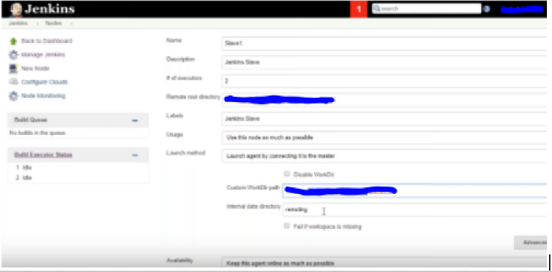

* Once the configuration is complete, you can see the slave machine on the dashboard.
* Download the **jar** file and copy the command provided to run the file.
* Run the command to start the slave node. Refer the screenshots given below:

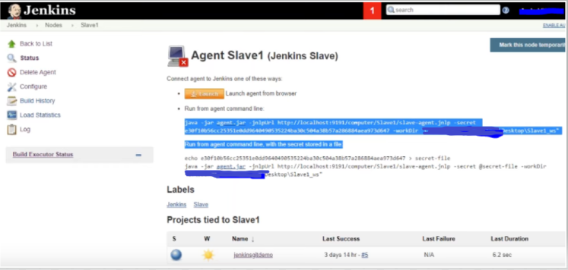

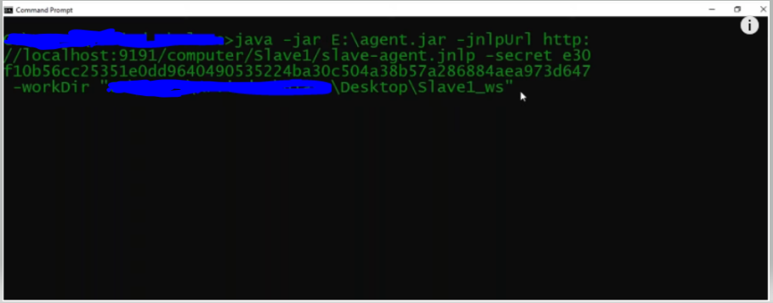

* Once the node is connected, click on the **Launch** button in Jenkins to start the slave machine.

**Step 9.2.3:** Build job with slave machine

* Create a new freestyle job.
* In the configuration page, check the **Restrict where this project can be run** option as shown in the screenshot below:

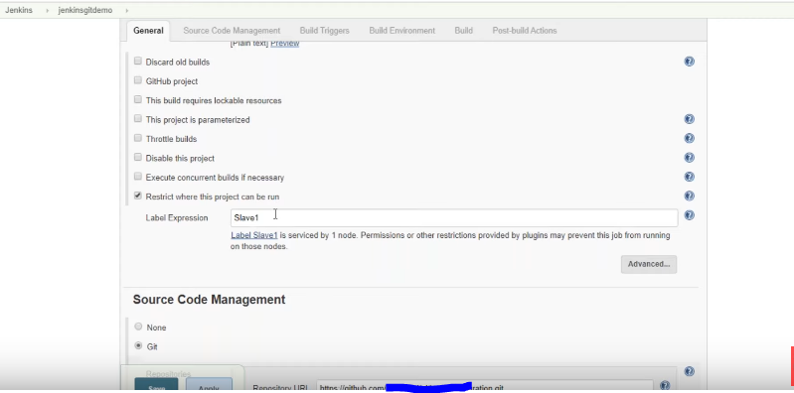

* Provide the URL to the repository of the source code in the **Source Code Management** section.
* Build the job and check the output in console.

**Step 9.2.4:** Push the code to your GitHub repositories.

* Open your command prompt and navigate to the folder where you have created your files.

**cd <folder path>**

* Initialize your repository using the following command:

**git init**

* Add all the files to your Git repository using the following command:

**git add .**

* Commit the changes using the following command:

**git commit . -m “Changes have been committed.”**

* Push the files to the folder you initially created using the following command:

**git push -u origin master**